K4 Companion
An application for remote control of the Elecraft K4 series SDR transceiver

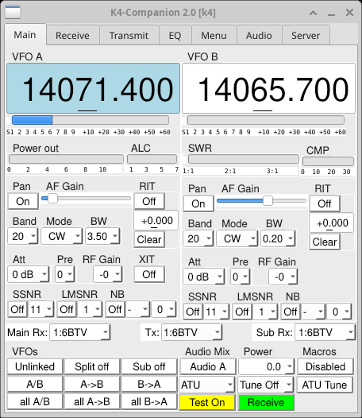

Developed by Dale Farnsworth, W7DA

Based on a simple utility originally devised by Charles Powell, NK8O

Revision date: October 5th 2026
The current version of K4 Companion is 2.0
Table of Contents

Introduction 1
License 2
Windows Installer & Binaries 3
Installation on Linux 4
Running K4 Companion 5
Remote Access 6
Configuration: Server Tab 7
Operation and Controls 9
Panadapter Window 13
Receive Tab 15
Transmit Tab 16
EQ Tab 17
Menu Tab 18
Audio Tab 19
CW Window 21
Keying Tab 24
Macros Window 26
Debugging 28
Notes on Operation 29
Recent Revision History 30

Introduction

K4 Companion is an application written in python3 that can remotely control an Elecraft K4 transceiver via TCP/IP. It controls the main K4 features, including remote audio, and new features are being added all the time.

Version 2.0 is a major update. The user interface has been rebuilt on Qt (PyQt6), so it looks different on every platform. New in 2.0 are a panadapter and waterfall window for each receiver, and a keyer: K4 Companion can now send CW from your own paddles or straight key connected to the computer, with a sidetone it generates itself. Of course, it can also be used with an external keyer. Connections to the K4 are now encrypted by default.

K4 Companion began life as a simple macro-sending program called K4Macro-Python, created by Charles Powell, NK8O. It has now grown into a full-fledged remote control program for the K4.

Please send problem reports either: by sending an email, by entering an issue on github, or by making a pull request. Problem reports and suggestions are greatly appreciated.

Dale Farnsworth, W7DA
dale@farnsworth.org

License

Copyright (C) 2025-2026 Dale Farnsworth
#
# This program is free software: you can redistribute it and/or modify
# it under the terms of the GNU General Public License as published by
# the Free Software Foundation, either version 3 of the License, or
# (at your option) any later version.
#
# This program is distributed in the hope that it will be useful,
# but WITHOUT ANY WARRANTY; without even the implied warranty of
# MERCHANTABILITY or FITNESS FOR A PARTICULAR PURPOSE. See the
# GNU General Public License for more details.
#
# You should have received a copy of the GNU General Public License
# along with this program. If not, see https://www.gnu.org/licenses/

Windows Installer & Binaries

A Windows installer and Windows binary executable files are available. You may need to disable Windows security briefly to download the installer. After downloading, double click the installer file, then select the desired options. The installer places all files in the installation folder, which by default is the folder k4companion in the user’s home folder. The executable program, k4companion.exe, a version of it with a console for debugging, k4companion-debug.exe (see Debugging), and a user manual are installed in the installation folder. A Start Menu entry and a desktop shortcut are also optionally created.

NOTE: The file opus.dll, a mandatory dependency, is also placed in the installation folder. It must remain in the same folder as k4companion.exe for proper operation. K4 Companion has been tested on both Windows 11 and Windows 10. It is built with Python 3.14.

If preferred, manual installation is possible. The two files needed to run under the Windows operating system are:
- k4companion.exe
- opus.dll

The two files should be placed together in a folder of your choice.

A note regarding Windows Defender: The Defender reaction will range from none at all, to identifying K4 Companion as a virus. If identified as a virus, Defender will quarantine the executable and ask if you want to delete it. Instructions regarding bypassing Windows Defender are found at https://answers.microsoft.com/en-us/windows/forum/all/how-to-allow-an-app-through-windows-defender/caab364c-9e65-448e-8635-98721be847ba

To use K4 Companion from outside your local network, see Remote Access.

Installation on Linux

Here are the items one needs to take full advantage of K4 Companion and all its features:

- A computer capable of running a full installation of Python is needed. This has been tested with Xubuntu, Debian 12, Chromebook, various iterations of the Dell XPS series, and several Lenovo laptops, and even an Evolve III notebook, running a variety of Linux flavors.
- Install Python3. This is pre-installed on most Linux distributions. Python 3.13 or later is needed for the encrypted connection on port 9204; with an older Python, use port 9205.
- Install pip3, required for the remaining dependencies.
- Install the Opus and PortAudio libraries, which K4 Companion’s audio uses, from your distribution’s packages. On Debian and Ubuntu: sudo apt install libopus0 libportaudio2
- Install the Python packages with pip: pip3 install PyQt6 pyqtgraph pyyaml opuslib numpy sounddevice PySocks python-rtmidi pyserial
- For access from outside your local network, see Remote Access.

Note: recent versions of Debian, Ubuntu and some other distributions refuse to install packages with pip outside a virtual environment, reporting an “externally-managed-environment” error. In that case, create one (on Debian and Ubuntu, install the python3-venv package first) with python3 -m venv ~/k4companion-venv, install the packages with ~/k4companion-venv/bin/pip3 install followed by the package names above, and run K4 Companion with ~/k4companion-venv/bin/python3 k4companion.

For macOS, see the separate K4 Companion MacOS Installation guide.

Running K4 Companion

There are several ways to run K4 Companion, depending on the operating system. To run the script directly, the file must be marked as executable. Under Linux and Mac OS, this can be done immediately after downloading the script. In a terminal window and using the command line, issue the command chmod +x k4companion . No modifications of the Windows executable files are needed.

Methods for starting K4 Companion:
- From a Linux terminal issue the command python3 k4companion, or if the file has been made executable the command ./k4companion, in the directory where the script is located.
- To start the Windows binary navigate to the file in the chosen folder, then either click on k4companion.exe or highlight and press ‘enter’
- If the Windows installer has been employed, K4 Companion can be run from the Start Menu or a Desktop icon if either was created at installation time.
- For access from outside your local network, see Remote Access.

Note for Linux users: If you create a shortcut or desktop launcher for K4 Companion, give the full path to k4companion in it, since a launcher does not start in the folder that holds it.

Remote Access

On your local network, K4 Companion connects to the K4 directly. To use it from anywhere else, the K4 must be reachable from the Internet, which can be done in several ways:
- Port forwarding. Forward port 9204 on your router to the K4, and enter your external IP address, or a name you have created with a service such as DynDNS, as the K4’s address on the Server tab. If your router forwards a different port to the K4, add that port after the address. When operating from a single remote address, it is possible to “open” your router to accept only that address.
- VPN. A VPN, such as Tailscale (https://tailscale.com) or WireGuard, gives access to your internal network without forwarding ports.
- SOCKS 5 proxy. Enter the proxy’s address on the Server tab. A proxy connection offers greater flexibility in connection options than opening the router to a single address.
- SSH tunnel. An SSH ‘tunnel’ to the K4 can also be used.

Since version 2.0, K4 Companion connects by default on port 9204, the K4’s encrypted (TLS) port, which K4 to K4 connections also use. Earlier versions used port 9205, which is not encrypted; it can still be used by adding :9205 to the K4’s address on the Server tab, and is then the port to forward.

Remote connections must be enabled on the K4, with a password and the number of remote connections allowed (see Configuration: Server Tab). K4 Companion and another K4 can be connected at the same time if the K4 allows more than one remote connection.

If you are not present at your K4, a way to remotely turn on your K4 is also needed. Please refer to the K4 User Manual or any of several forums that address this function.

Configuration: Server Tab

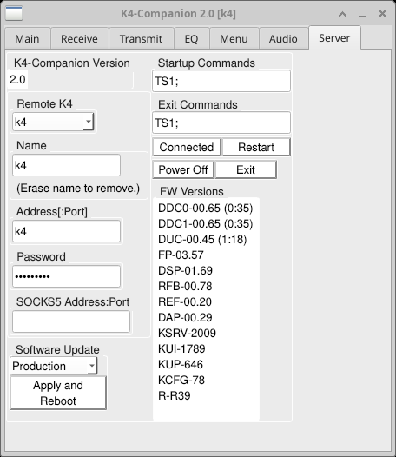

Server configuration is done through the ‘Server’ tab. Configuration parameters must be entered once but will be saved for future use. The required items are:

- Specifying the ‘Name’ for the profile. Each new profile is given a default name, but it can be changed when the profile is created. Up to 25 profiles are possible with K4 Companion. To add one, choose *new* in the ‘Remote K4’ pull-down; to remove one, erase its name. In the ‘Remote K4’ pull-down after a profile is created, select the name for the connection. If only a single connection is created, K4 Companion will connect automatically. Otherwise the program opens to this page so the profile can be selected.
- The address of the K4 to be controlled. This can either be the serial number of the radio in the form K4-SNxxxxx.local, or it can be the actual IP address of the K4. There are reports that using the actual IP address makes the connection more responsive, and the serial number setting may not work under Windows. Your experience may be different. For remote operation, see Remote Access. The default is port 9204, which is encrypted. To use the K4’s unencrypted port instead, add :9205 after the address.
- The password to access your K4. For all remote control this must be set on the radio. The default password will NOT work. In addition, the number of connections to your K4 must also be specified. This can be set to one, and up to four connections allowed. No connections will be permitted if the parameter is set to zero or left at default.
- SOCKS 5 proxy An optional SOCKS 5 proxy is supported. The SOCKS 5 proxy address is entered in the ‘SOCKS 5 Address:Port’. The default port is 1080 and need not be specified unless a different port is used.
- Once information is entered, K4 Companion will attempt to connect. If the information is entered correctly and the server is running, a connection will be established. Hint: enter password information first, then the server address
- The Startup and Exit commands are sent to the K4 on startup and exit respectively. By default, they put the radio in Test Mode when K4 Companion opens and return it to Test Mode for safety when the program exits. These can be changed at your own risk!

Firmware upgrades or downgrades, and beta releases, can be installed remotely. Choose the release in the Software Update pull-down (Production, Beta, or Previous Prod., the previous production release), then click Apply and Reboot to have the K4 restart and install it. The FW Versions list on the right shows the firmware installed in the K4, not the releases available. Please check on the Elecraft site for information on the various releases and features, or other information.

On the right hand side, the connection status is shown. ‘Power Off’ turns off the K4. ‘Exit’ will close K4 Companion without shutting down the radio. ‘Restart’ can be used if configuration is changed or if there is a brief loss of connectivity, i.e., the Internet connection drops briefly or network congestion causes a problem. ‘Connected’ reflects the connection status. If the connection to the K4 is lost, K4 Companion says why and tries to connect again.

While connected to a K4, the K4’s firmware versions are displayed in the lower right.

The version of K4 Companion is displayed at the upper left.

Operation and Controls

The operation of many of K4 Companion controls is self-explanatory. Each VFO can be linked, operated independently, swapped, placed into Split mode, Sub-receiver mode, or both simultaneously. A diversity receive selection is also available. Various other functions are controlled in the main tab, including preamps, attenuators, RF gain, ATU functions, and audio controls.

The VFO that will transmit is shown in light blue, so it is possible to see at a glance which VFO will transmit when the radio is keyed. This avoids confusion when using Split or Sub modes.
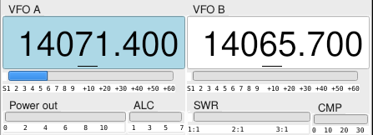

In the image above, VFO A will transmit. If Split were on, VFO B would be light blue instead. The details available at a glance are the frequency of each VFO, the S-meter reading for each VFO (if both are active), power out either 0-10 watts or 0-110 watts, SWR, and for phone operation, compression. When transmitting, the active transmit VFO turns dark blue.

The VFO boxes also support direct entry. The increment can be changed between 1 Hz and 10 kHz with the keyboard arrows ←→ or clicking with the mouse or touchpad. The active scroll rate increment is underlined. The Up ↕ Down arrows on the keyboard or the mouse wheel can be used to change the frequency by the current increment while the VFO frequency is selected.

Pull-down menus shown in the images above are available for each VFO to set the following parameters:
- Band selection, 160 through 6 meters
- Mode selection, including all available modes for the K4 (does not include digital sub-modes)
- Bandwidth selection from 50 Hz to 5 kHz (for AM reception)
- RF attenuation in 3 dB steps up to -21 dB
- Preamp selection − none, 1, 2, or 3 (depending on the band)
- RF gain, in -10 dB increments down to -60 dB. Note: Elecraft recommends use of Attenuation rather than RF gain. Attenuation reduces the signal to the ADC. This is different from the K3
- NB (noise blanker), SSNR and LMSNR (noise reduction), each with an On/Off button and a level. Selecting R in the SSNR level resets its noise estimate.
- Pan opens the panadapter window for that receiver (see Panadapter Window)

Each of these selections will “scroll” with the mouse wheel or up/down arrow keys, in the same manner as the VFO controls.

The following controls are fairly self-explanatory, at least once you are familiar with K4 Companion.

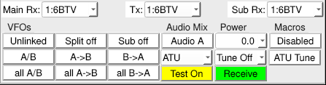

When the application opens, by default it sets the K4 to Test Mode, as shown above. This button is yellow when Test Mode is on. It is also possible to check ALC and compression without actually transmitting.

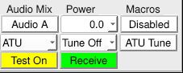

The Transmit/Receive button can be clicked to toggle between transmit and receive and displays the current state. It also changes state when the T/R mode is changed by another function. Pressing the space bar will toggle T/R if the focus is on the main window.

Audio output selection is labeled “Audio Mix”. Available selections are A, B, or A+B. If other selections are specified via macros, these will be reflected in the pull-down, but they are not directly selectable from K4 Companion. XIT is turned on with the XIT button under VFO A’s controls, and its offset is set in the RIT digit box, which XIT shares. The box and the buttons turn green for RIT, blue for XIT, and turquoise when both are on. Both RIT and XIT frequency delta can be selected directly or by scrolling with a mouse wheel or keyboard up/down arrows. Transmit power can be selected either with pull-down presets or by direct entry. The Macros button opens the Macros window (Enabled) or closes it (Disabled); see Macros Window.

In the next row of buttons the options are:
- Linked VFOs or Unlinked. Elecraft calls this “Band Independence”

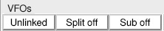

- Split on, Split off. This button turns split mode on or off; it turns yellow when split is on.
- Sub activates the K4 sub-receiver. This can be used either with Split mode to move the transmit VFO to B, or without. The main and sub-receivers have separate volume slider controls, located below the VFOs and meters.

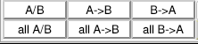

The middle row of the VFO section is self-explanatory.
- Swap VFOs A/B (may be activated repeatedly to maintain different modes, for example)
- VFO A to B
- VFO B to A

The final row “All” swaps or copies all parameters, equivalent to a “double tap” of the buttons on the K4.

Antenna selection is available in the row beneath the VFOs, for the transmitter (Tx) and for the Main and Sub receivers. These combinations mirror the selections available on the K4, and various combinations can be set in Macros (see Macros Window.)

ATU controls function via pull-down:
- ATU = ATU active
- Bypass = ATU bypassed
- Tune = normal ATU function = single tap on the K4
- TUNE = extended tune = double tap on the K4.

The “Tune Off” pull-down has two additional states:
- Tune produces a carrier at the full (selected) power
- Tune LP produces a low power carrier at 5 watts

The remaining button, “ATU Tune” here, shows the most recently used tune function and that function can be repeated by clicking on this button.

To EXIT K4 Companion, use the window ‘X’ at the top of the frame. Location will depend on your operating system. For Windows and Linux this is typically found at the upper right. On MacOS, it is usually on the left.

Panadapter Window

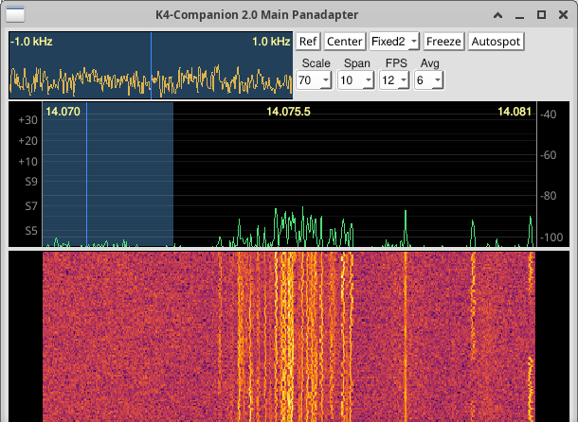
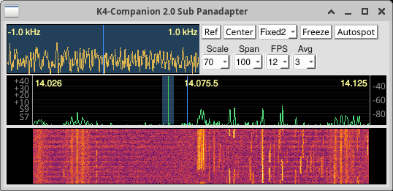

Each receiver has a Pan button on the Main tab. It opens a panadapter window for that receiver: the K4’s spectrum display (the trace) above a waterfall, with a mini-pan, a close-up of the signals around the VFO frequency. The frequencies of both VFOs are marked, and the receive bandwidth is shaded. The left edge of the trace is scaled in dB, and the right edge in S-units. Clicking Pan again brings an open window to the front. The images show the Main receiver’s panadapter at the top and the Sub receiver’s below it. The window’s position and size are remembered.

Clicking on the trace, the waterfall or the mini-pan tunes the VFO to that frequency. Clicking in the bare strips either side of the waterfall moves half the display span down (on the left) or up (on the right). The left/right arrow keys on the panadapter change the frequency: 1 kHz on the waterfall, 100 Hz on the trace, 10 Hz on the mini-pan and 1 Hz on the button area. The divider between the trace and the waterfall can be dragged.

The controls along the top of the window are:
- Span − the width of the display
- Scale − the height of the display in dB, as set on the K4
- Ref − sets the reference level of the display from the signals it is showing
- Center − centers the display on the VFO frequency
- Fixed Tune − Track, Fixed1, Fixed2, Slide1, Slide2 or Static, the K4’s fixed-tune modes
- FPS − how many times a second the display is updated
- Avg − how much the trace and mini-pan are smoothed
- Freeze / Unfreeze − stops and restarts the display
- Autospot − tunes to the CW signal nearest the VFO (CW and CW-R only)

Span, Scale, FPS, Fixed Tune and Freeze are the K4’s own settings, so they apply to both panadapters and match the K4’s display. Please refer to the K4 User Manual for details of each.

Receive Tab

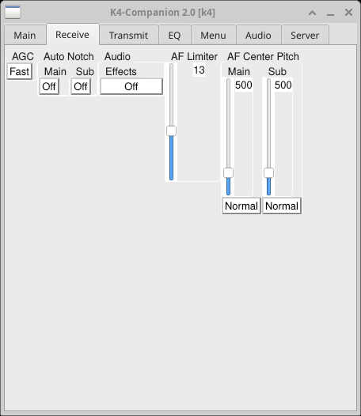

Controls for AGC, Auto Notch (SSB) and Audio Effects are in the top row. The function of each is explained in the K4 User Manual. Options for Audio effects include
- Simulated Stereo – introduces a slight delay in L − R audio to reduce listening fatigue
- Pitch map − moves audio from left to right as the deviation from the center frequency decreases or increases
- Off − removes all tuning and listening effects

Note that the AF limiter only functions if the AGC is “Off”. This prevents extremely loud signals from blasting through at full-volume if the AGC is absent. AF Center Pitch functions by mode, and returns to the last-used settings when changing modes. The Noise Blanker, SSNR and LMSNR noise reduction controls are now on the Main tab, under each receiver. They are explained in the K4 user manual. Recommended settings vary by band conditions and personal preferences.

Transmit Tab

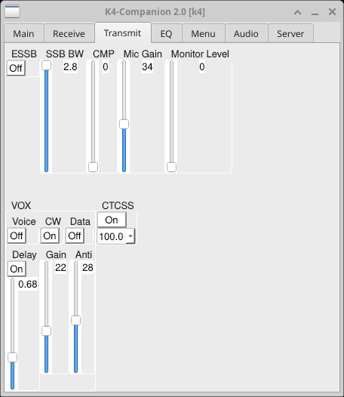

- Transmit controls include ESSB (wide-band, high fidelity SSB). When selected, the SSB bandwidth varies between 3 kHz and 4.5 kHz
- SSB bandwidth for standard or CESSB (Controlled Envelope SSB) ranges from 2.4 to 2.8 kHz
- CMP − sets the level of transmit audio compression; when set above 0, it automatically enables CESSB
- Mic Gain − set to optimize SSB drive
- Monitor level − useful primarily if using K4 Companion for ancillary control of the radio while operating in the shack. No audio is returned when operating remotely. This control is independent of Sidetone Volume in the CW window.
- VOX on/off with sliders to select parameters
- CTCSS – sets access PLTM tones for FM repeater operation

EQ Tab

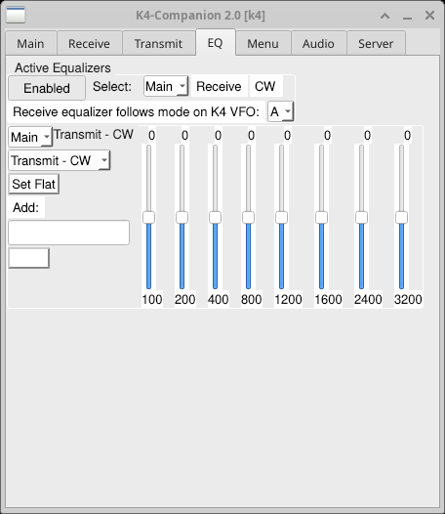

Transmit and Receive equalization can be enabled or disabled, and be set by mode. These are personal preferences. When enabled the settings on the K4 are altered. The K4 settings do not revert to previous settings if the Equalizers on K4 Companion are disabled.

Please refer to K4 forums or the K4 User Manual for recommendations.

Menu Tab

The Menu tab reproduces all of the K4’s menu functions. These functions are covered in the user manual. The configuration menu is a long, scroll-able list. When an item is selected, it appears in pink. Then a secondary widget opens that offers the menu choices. Some of these are simple YES/NO selections, others present a list, and some have a slider to select a value for the menu item.

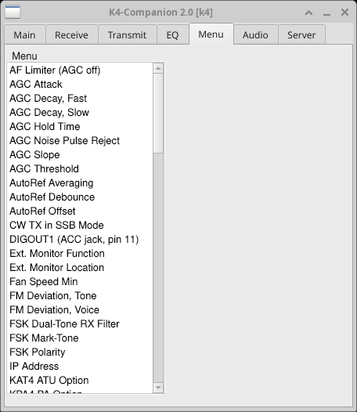

The image shows the start of the menu list. Please be sure to read the K4 user manual carefully. Changing menu settings without due consideration can have unexpected results.

Audio Tab

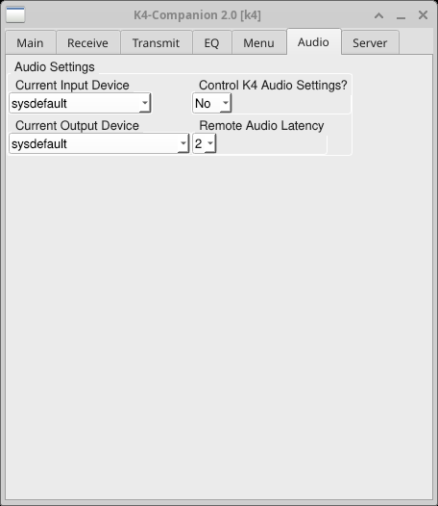

The Audio tab contains these settings:
- Current Input Device
- Current Output Device
- Exclusive Input Device? and Exclusive Output Device? (Windows only)
- Control K4 Audio Settings?
- Remote Audio Latency

Typically the Input/Output settings will be correct when K4 Companion opens and they need not be changed. These settings vary by operating system. Audio connections are generally set to ‘default’ in a Linux installation but the choices may vary by OS ‘flavor’, and sound systems installed. In Windows there are a variety of settings, but often the choices mention ‘Speaker’ and ‘Microphone.’ Mac users should consistently see settings that mention ‘Speaker’ and ‘Microphone’ since there is less variability in the hardware.

On Windows, each device also has an Exclusive setting. Exclusive mode lets K4 Companion have the device to itself, which lowers the delay of the sidetone when keying from paddles or a straight key. No other program can use the device while K4 Companion has it. The default is No. If a device cannot be opened exclusively, K4 Companion says so and shares it instead.

Control K4 Audio Settings? If you are using K4 Companion to control the radio while sitting in the shack, this can be set to Yes. Otherwise for remote operations, set it to No. See Notes on Operation below. Once this tab is configured, the settings are saved automatically. No changes are needed unless something in your operational configuration changes. The equalizer settings do change on the radio, regardless of the settings selection in the Audio tab. Frequent remote users may want to set the radio’s audio to zero, and ‘Control K4 Audio Settings?’ to ‘No’. In this way, the radio will be silent during remote operations.

Remote Audio Latency sets the K4’s own latency for the audio it streams, from 0 to 7. It is useful for remote connections where there is considerable jitter on the network path. The lower settings are usually acceptable in the home network setting. A higher setting could be needed for Internet connections with higher variability, if the audio breaks up. Increasing this setting adds additional delay to the received audio.

CW Window

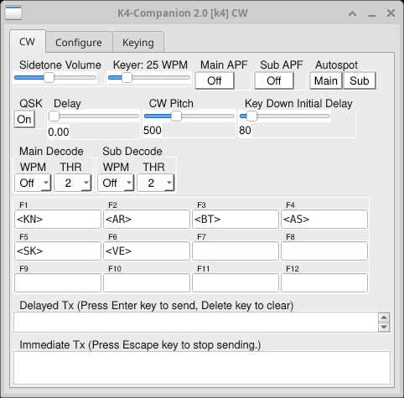

K4 Companion has a CW functionality via the keyboard. There are a number of user-configurable macros that are easily set. These can be used sequentially in any combination. The typing buffer holds any text that is set until the user hits ‘enter’. The text will be sent and shown below in the Tx box. A cursor follows the text that is being sent. The sidetone will also reproduce each character audibly, unless the Sidetone Volume is set to zero. The CW window has three tabs: CW, Configure and Keying (see Keying Tab). Keyer speed and sidetone volume controls are on the upper left of the CW tab. The APF – Audio Peaking Filter − and Autospot each have separate Main and Sub selections. No spot tone is available remotely.

Several combination items require special characters to send correctly, but they have designations common to Elecraft. For example, ‘AR’ is sent with ‘+’ and ‘SK’ is sent with ‘*’. Other prosigns include ‘(’ for KN, ‘=’ for BT, ‘%’ for AS, ‘_’ for AA (used in sending message traffic) and finally ‘!’ for VE. To label these items, use the “&” as the divider to differentiate the label from what is actually sent. The label can be anything you like that tells you what is being sent. Symbols that will not transmit on the K4 are excluded and a brief warning appears if any is entered in the text box.
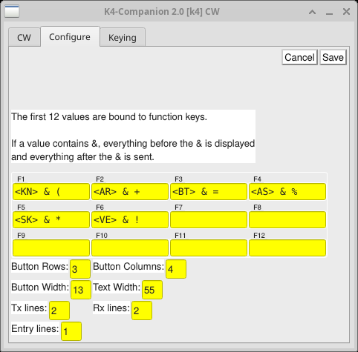

Editing the buttons is accomplished with the ‘Configure’ tab. The ampersand (&) is used between the label and what is actually sent. To finish editing, click ‘Save’. Changes can be made at any time. In the default configuration there are 20 macro buttons. The number of rows, columns, and other configuration can be edited to taste in the ‘Configure’ mode, but there is no harm in leaving the default configuration. One might use one row for CWT, another for hunting parks, and another for chasing DX. There is no distinction between upper case and lower case letters when sent. Brackets <> can be used in button labels but not to transmit. These characters are disabled on the transmit side of the buttons.

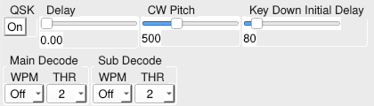

Some of the less obvious Elecraft CW designations are installed by default on the primary setup. These can be moved, changed, deleted, or edited to suit your preferences. Finally, sending can be quickly canceled by hitting ‘Esc’ − escape.

QSK on and off, the Delay, CW Pitch and Key Down Initial Delay are also set on the CW tab, as are the Main and Sub CW decoders (WPM and THR).

When sending from the keyboard, the sidetone comes from the K4. If it is absent despite the level being turned up, check in the Menu tab of the Main window. “TX Monitor Level, Remote” must be set to zero. If it is set to -1, there will be no sidetone heard on transmit. When keying from paddles or a straight key, K4 Companion generates the sidetone itself (see Keying Tab).

Keying Tab

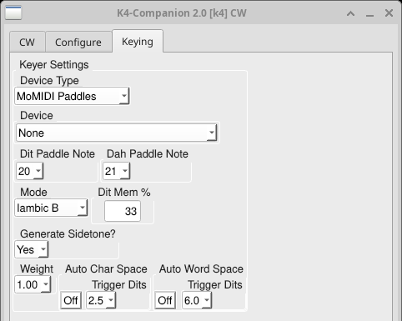

K4 Companion can key the K4 from paddles or an external keyer or straight key connected to the computer. Its keyer forms the dits and dahs, sends them to the K4, and plays a sidetone on the computer, so that you hear your sending without waiting for the audio to come back from the K4. The Keying tab of the CW window sets it up. The keyer works only when the K4 is in CW mode, and it uses the keyer speed set on the CW tab.

Device Type selects how the key is connected:
- None − no key is connected
- MIDI Paddles or MIDI Straight Key − a MIDI keying interface. Choose the MIDI device, and the note sent by each paddle (Dit Paddle Note and Dah Paddle Note) or by the key. Examples of devices supporting this interface are the HaliKey Midi, electronics.halibut.com/product/halikey/, and the CTR2 series, ctr2.lynovation.com/category/products/.
- Serial Paddles or Serial Straight Key − paddles or a key wired to a serial port. Choose the port, and the signal (DSR, DCD, CTS or RI) each paddle or the key is on
- Vail Adapter − a Vail adapter, www.vailadapter.com, chosen from the MIDI devices. Its own keyer modes are offered in the Mode list

An external keyer is seen by K4 Companion as a straight key, so that is the setting to be used for external keyers.

Mode (paddles only) selects Plain Iambic, Iambic A, Iambic B or Ultimatic. In Iambic B, Dit Mem % is the leading percentage of a dah in which releasing a squeeze sends no dit after it. Hovering over it gives a reminder.

Generate Sidetone? chooses whether K4 Companion plays the sidetone itself. Yes is recommended unless using a device with its own sidetone. Its volume follows Sidetone Volume on the CW tab. While you are keying, K4 Companion mutes the K4’s own monitor sidetone, so that it is not heard as well, and restores it afterward. The sidetone is heard a little after the paddle closes, by the delay of the computer’s audio output; on Windows, exclusive mode on the Audio tab shortens it.

Weight, from 0.90 to 1.25, lengthens each dit and dah (above 1.00) or shortens it (below 1.00), taking the difference from the space after it, so the speed is unchanged. 1.00 is standard.

Auto Char Space and Auto Word Space, when On, lengthen a pause to a full character space or word space. Trigger Dits is how long a pause, in dits, counts as one: 1.5 to 3.0 for a character space (2.5 by default), and 5.0 to 7.0 for a word space (6.0 by default).

Macros Window

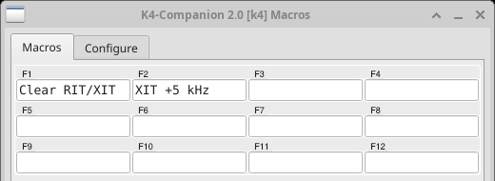
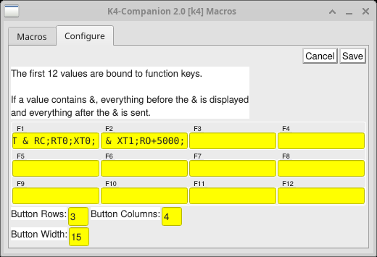

Macros add great flexibility and control to the K4. Each button in the Macros window sends a string of K4 commands, and its label is shown briefly when it is clicked. The first 12 buttons are also bound to the function keys F1 to F12, which work when either the Main window or the Macros window has the focus.

The Macros button on the Main tab opens the window (Enabled) or closes it (Disabled), and K4 Companion remembers which. The window can also be closed by clicking the X in its corner.

The buttons are edited on the Configure tab. Each field holds a button’s label and the commands it sends, separated by an ampersand (&) in the same way as in the CW window: everything before the & is shown on the button, and everything after it is sent. A field with no & shows and sends the same text, and a semicolon is added to the end of the commands if it is missing. Click Save to keep the changes, or Cancel to discard them.

Button Rows and Button Columns, each from 1 to 20, set the size of the grid, 3 rows of 4 buttons by default, and Button Width sets how wide each button is.

Please refer to the Elecraft K4 Programmer’s Reference or various K4 user forums for more information regarding macro strings.

Debugging

No guarantee is made that this software will run on a particular machine or distribution. However, debugging information may be useful to the developer. Problems can be reported by opening an issue at https://github.com/DaleFarnsworth/K4-Companion/issues. To initiate debugging, use the ‘-d’ option: ./k4companion -d . This will show a running list of actions by the script onscreen. To save the debugging information to a file, use ./k4companion -d > mydebugfile 2>&1. The debug file can be named anything you like and the file will be created if it doesn’t exist already. To append an existing log file, use ./k4companion -d >> mydebugfile 2>&1. The file can then be posted or e-mailed to Dale, W7DA. Information from dmesg may be helpful as well: sudo dmesg , although more likely if there is a system failure somewhere and not necessarily with K4 Companion.

To include the keyer’s timing, which helps with a keying problem, add --da keyer: ./k4companion --da keyer >> mydebugfile 2>&1.

To include the audio’s timing, which helps when the received audio is choppy or breaks up, add --da audio: ./k4companion --da audio >> mydebugfile 2>&1.

On Windows, k4companion.exe has no console, so its debugging information cannot be seen. Use k4companion-debug.exe instead: the same program with a console, taking the same options. In a Command Prompt, in the folder holding it, use k4companion-debug -d > mydebugfile 2>&1, adding --da keyer or --da audio as above if needed. The installer puts it in the installation folder, beside k4companion.exe. In any case, report the problem in as much detail as possible, and copy any error messages that do appear.

Notes on Operation

Audio functions on Linux can sometimes be challenging. A working knowledge of ALSA, alsamixer, and alsactl is useful. Pavucontrol can assist with selecting the correct audio input and output. Be sure to check the Configuration tab in pavucontrol, and if audio is not working, try other combinations. These may include “Stereo Duplex,” “Play HiFi quality Music,” and “Pro Audio,” among others.

Regarding Windows: I have noted it is prone to random audio failures, including disabling the audio for unknown reasons. You might have to dig into the subsystem a bit. I recommend using the Sound App, not the control panel. Use mmsys.cpl to access the Sound App. Control panel is often not very enlightening and the Sound App gives more information. As always, YMMV − your mileage may vary!

An experiment proved that K4 Companion will run on WSL – Windows Subsystem for Linux, but it is not easy to set up, and there are quite a few stumbling blocks. Choppy audio is probably the greatest impediment, probably due to adding extra layers of complexity to the audio subsystems. It does run under Parallels in macOS, as well as other emulators. Significant improvements have been made to the audio subsystem of K4 Companion, but there are simply limits to the way various operating systems handle sound reproduction.

Enjoy!

Charles
NK8O
VE3ISD
5H3DX
nk8o@arrl.net

Recent Revision History

v2.0:
Rebuild the user interface on Qt (PyQt6)

Add a panadapter and waterfall window for each receiver

Add a keyer for paddles or a straight key connected to the computer
MoMIDI, serial and Vail adapter devices; Plain Iambic, Iambic A,
Iambic B and Ultimatic modes; weighting; automatic character and
word spacing.

Generate the sidetone locally when keying from paddles or a key
The K4's monitor sidetone is muted while keying.

Connect to the K4 on port 9204, encrypted with TLS, by default

Move the NB, SSNR and LMSNR controls to the Main tab

Add an SSNR reset selection and a 1 kHz bandwidth selection

Add exclusive mode for audio devices on Windows

Remove the Receive Latency setting

Replace the CW window's More tab with a Keying tab
The More tab's controls are now on the CW tab.

Split Autospot into separate Main and Sub buttons

Say why a connection was lost, and try to connect again

v1.6.2:
Add support for setting SSNR noise reduction

v1.5.8:
Fix AF Center Pitch "Normal" button
Clicking the button would cause the associated slider to briefly go
to its maximum value before going to the "Normal" value. Now it doesn't
go to the maximum value.

Properly show/hide CW window on split mode change

Fix the release version in the FW Versions list

Change the Transmit button color to match the VFO

Make audio device settings apply to all profiles
Done so the user only has to set them once, not for each profile.

v1.5.7:
Add hidden reverse_mouse wheel direction option

